
BROKEN FUNCTION LEVEL AUTHORIZATION (BFLA) REPORT
DEMILADE ADEISRAEL

Summary
Broken Function Level Authorisation is an access control vulnerability whereby a user can perform unauthorised administrative actions.

Objective
The objective of this assessment was to determine whether a user can perform administrative actions by manipulating API endpoints.

Test Summary
An authenticated, low-privilege user can abuse an administrative endpoint to delete video files belonging to any other platform user. Initially, unauthorized deletion attempts returned a verbose error message leaking hidden internal API routing components. Because the back-end fails to validate user roles on administrative functions, standard users can invoke this hidden path to perform restricted, highly destructive actions (Vertical Privilege Escalation).

Tools Used

Tool | Purpose
Burp Suite | Intercepting, modifying and replaying HTTP requests
Postman | Sending and validating API requests
crAPI | Intentionally vulnerable API security lab

Severity
Risk Rating | CVSS v3.1 Score | Vulnerability Type | Target Endpoint
HIGH | 8.1 | CWE-285: BFLA | DELETE /identity/api/v2/admin/videos/{{video_id}}

Impact

HIGH (Destructive Integrity Loss)

Availability: High. By deleting video assets belonging to other users, the attacker directly destroys the availability of those resources for legitimate customers, disrupting core platform services.

Integrity: Threat actors can target specific competitors or randomly delete system data, resulting in irreversible data loss for legitimate customers.

Findings & Analysis
This section would contain the step by step process to which this BFLA vulnerability was exploited on crAPI. It would also contain screenshots from the lab to provide better understanding of the processes executed. These steps were carried out after creation of users “alice123@email.com” and “john123@email.com” on crAPI.

STEP 1 - Video Creation and Name update
After creation of the John123’s account, a video was uploaded to the profile (Figure 1). An unauthorised attempt to update the video’s name from Alice123’s account was initiated. Unsuccessful, the video name was updated on Alice123’s account instead (this was noticed as the “video_id” received in the response(id: 52) was different to that of the target(id:102))(Figure 2).

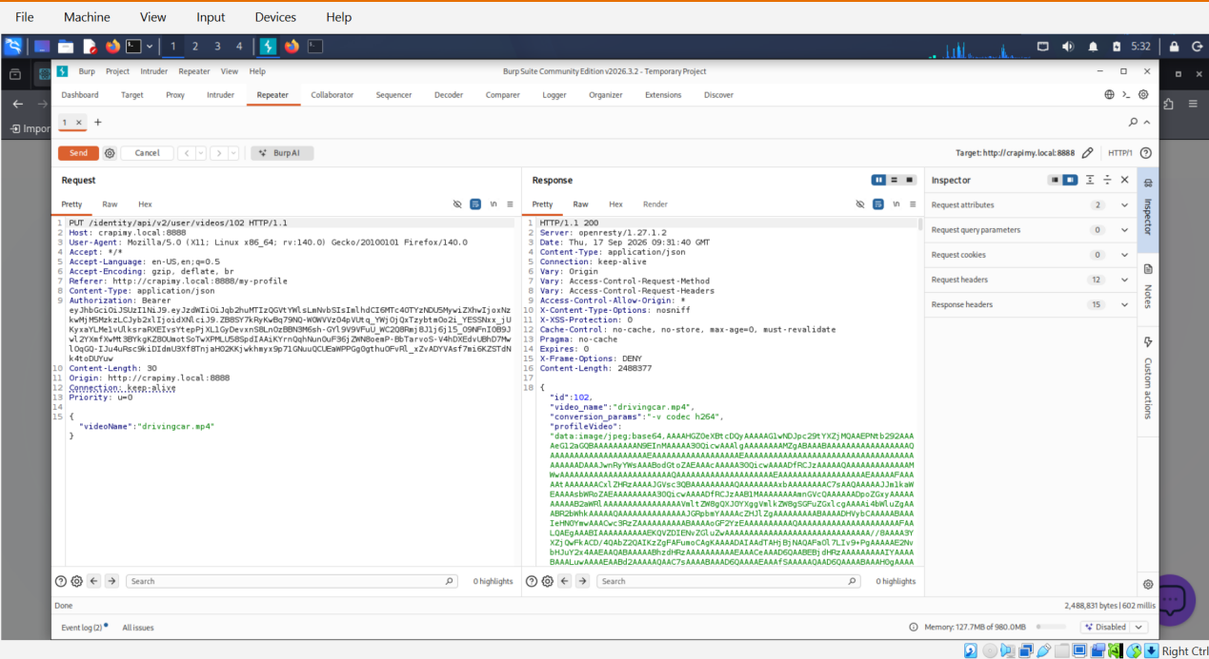
Figure 1

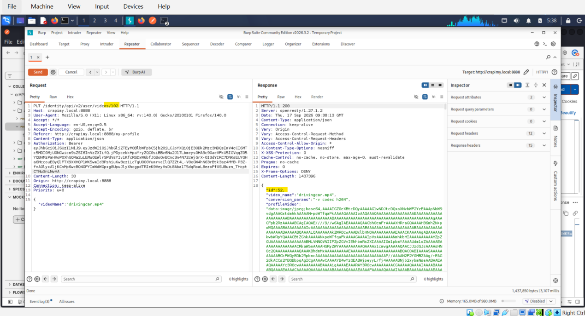
Figure 2

STEP 2 - Reconnaisance via Verbose Error Message
With the “PUT” request being unsuccessful, a “DELETE” request was performed on John123’s video (Figure 3).

Although unsuccessful, a 403 Forbidden response containing a verbose error string (“This is an admin function. Try to access the admin API”) gave hints on a way to bypass authentication (Figure 3).

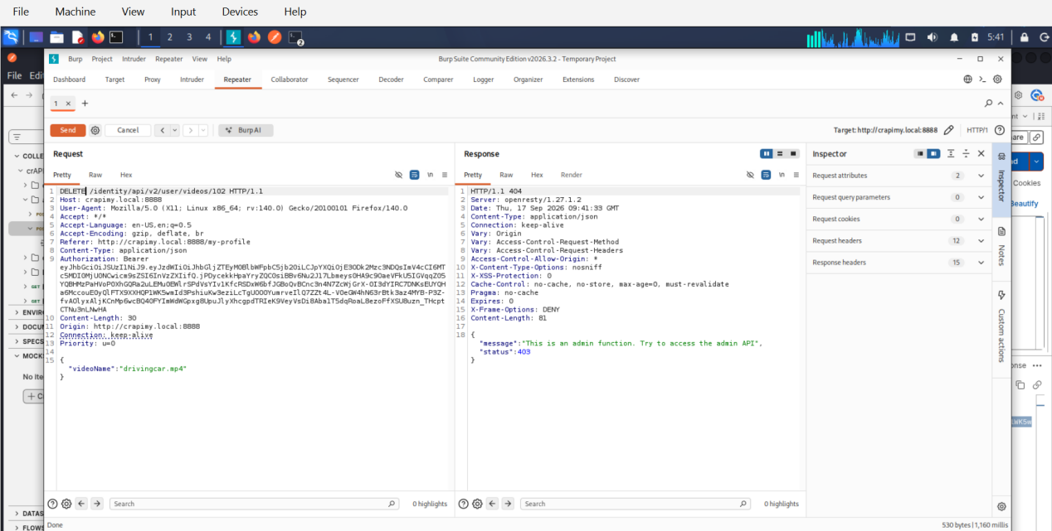
Figure 3

STEP 3 - Request Reconstruction
Based on the hint from the error message, the URI path was modified pattern while having a standard user’s token (Alice’s). The new DELETE request replaces the v2/user/ endpoint with v2/admin/ (Figure 4)
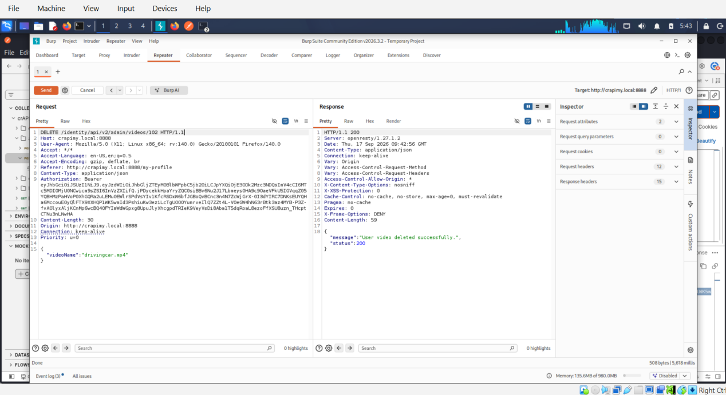
Figure 4

Remediation
- Disable Verbose Error Messages: Ensure production microservices do not leak stack traces, internal parameters, or endpoint paths to users.
- Role-Based Access Control (RBAC): Restrict access to administrative endpoints strictly to authorized roles within the controller layer
- Implement the Principle of Least Privilege: Deny access by default to any API path prefixed with /admin/ unless the user session explicitly satisfies administrative policy criteria at the API gateway tier.

Methodology

Risk Matrics Description
Factor Breakdowns
- Likelihood: HIGH (Certain / Trivial)

Attack Complexity (AC: L): Low. Exploiting this vulnerability does not require specialized conditions, precise timing, or advanced technical evasion techniques. It relies on standard browser proxy manipulation tools (Postman/Burp Suite).

Privileges Required (PR: L): Low. Any standard, self-registered user on the platform possesses the necessary access level to trigger the initial error message and execute the subsequent administrative API call.

User Interaction (UI: N): None. The exploit executes completely silently on the backend API without requiring the victim to click a link, open an attachment, or take any action.

2. Risk Matrix Calculation
By mapping a Medium Likelihood (dependent on finding the leaked path via error logs) against a High Business Impact (unauthorized, permanent deletion of application data assets), the vulnerability maps directly to a High Risk designation.

3. CVSS v3.1 Vector Breakdown
The assigned vector string CVSS:3.1/AV:N/AC:L/PR:L/UI:N/S:C/C:H/I:N/A:N formally indicates:

Attack Vector: Network (AV:N) — Exploit is launched remotely over the internet.

Scope: Unchanged (S:U) — The compromised administrative functionality affects resources within the same underlying application architecture context.

References
OWASP
Akamai
CVSS

